DARPA NEUSLEEP – Study B Procedure Protocol

STN Targeting/Anatomical MRI Scan
Filename: WANG_NEUSLEEP_STUDYB_00X

Screening and Subject Preparation
- Reception of participant at HDB Lobby
- Bring participant to UT BIC Waiting Area
- Perform/Check MRI Screening Form & Pittsburgh Sleep Quality Index Form
- Ask participant to change into scrubs in the change room
- Record participant’s height, birth year, and weight their weight.
- Go over consent form (brief overview of experimental procedure) with participant and sign.
- Bring participant into MRI Control Room.

Anatomical Scan
- Prepare MRI (clean, setup, sheets, cushion)
- Give earplugs to participant to use and bring them into the MRI machine. Position and place them in.
- Perform the following:
  - Scout Scan
  - T1 Weighted Anatomical Scan (~7 min)
- Bring participant out to MRI Control room
- Use 75% EtOH or cleaning wipe to clean skin on left temporal window.
- Place PseudoNEUSLeeP and repeat Scout Scan
- Repeat Step 7 until targeting alignment is correct.
  - Record distance to STN
  - Use recorded STN to determine focal depth parameters (DelayParameter) in Verasonics Vantage 64LE
  - Mark with medical markers placement.
- Remove PseudoNEUSLEEP, wipe with 75% EtOH
- Take participant out, clean MRI machine.

Post-Experiment
- Bring participants to change clothes
- Provide Instructions for Sleep Participants.docx form.

NEUSLeeP Sleep Study

A. Setup EEG Room (~10PM):
- Obtain key (with blue John Hopkins lanyard) in the upper cabinet of Desk 8 in BME 1.342.
- Go to SEA 2.546 and SEA 2.544 (Access Code: 1483*).
- Obtain a new set of clean bed sheets, blanket and pillowcase. Place them in the bed and set them in SEA 2.544.
- Turn on the computer and login in SEA 2.546.
- Unplug BrainVision power supply from charger, take BrainVision Ex with the 8-Channel Bipolar Input Box connected and connect it with the BrainVision power supply using a 4-pin grey connector at the back. Bring it into SEA 2.544 (BE EXTREMELY CAREFUL HANDLING THIS!).
- Take the fiber optic cable in SEA 2.544 and connect it to the BrainVision Ex and switch to “on” in the back of the amplifier and place it on top of the right bedside drawer.
- Go to the computer and check if the fiber optic cable is connected to the BrainVision USB adapter trigger box Input 1. If not, do so.
- Open BrainVision Recorder software -> Click open workspace -> select “NEUSLEEP-8CH-BIP”.
- Click on the “eye” icon on the top left to see if signals are being received. If not, check all procedures and connections.
- Next, make sure the USB cables labelled with “Camera” is connected. Start off with granting administration rights to yourself -> Open AMCap -> Select “USB Camera” -> Check if camera is operating.

B. Setup Verasonics Vantage 64LE (~10PM):
- Move the Verasonics Vantage 64LE stored either in SEA 2.546A or SEA 2.546B near to the computer.
- Move the medical stand with associated BNC cables to SEA.2544 sleep room and connect accordingly.
- Connect the “OUTPUT TRIGGER” BNC Cable to the male BNC cable labelled “1” connected to the BrainVision USB adapter trigger box.
- Connect 8-channel LEMO-00-BNC cable to Verasonics Vantage 64LE based on the labelled numbers.
- Powering Verasonics (IMPORTANT!)
  - Turn on the main power switch at the back of Verasonics first and wait for 1 min.
  - Turn on the computer after 1 min.
  - Turn on the HIFU power supply.
- Open MATLAB and in command prompt
  - Enter “activate”
  - Enter “VSX”
  - Adjust “DelayParameter” based on the distance to STN and the device #. -> Press “Run” (Refer to calibration and characterization table/curve).
  - Enter “DARPA_NEUSLEEP_STUDYB_100Hz_Protocol”
  - A window would pop up, check if you can increase the “High Voltage P5” slightly. If so, it is working. If it does not respond, turns blue or drops to 0.6. Restart MATLAB and HIFU power.
  - If error including “no connection” and “power”. Turn off HIFU power, close MATLAB and restart MATLAB.
  - IF ANY OTHER ERROR OCCURS, IMMEDIATELY TAKE A PICTURE, CONTACT KEVIN (5127367481) AND STOP OPERATING VERASONICS.
- Open Arduino.
  - Select COM port of Arduino Uno connected.
  - Open Serial Monitor -> Select 115200 baudrate. -> Check if serial terminal shows a prompt. If so, it is working.
  - If not, reupload the Arduino Code.

C. Pre-Screening of Subjects (~11PM)
- Bring subject to any of the clinical rooms.
- Have them change into comfortable clothing if needed.
- Go over experiment procedure of the study to the subject.
- Perform Stanford, Epsworth, STAI-S questionnaire (https://forms.gle/Z57iTSeC6treg23j9).
- Ask if there are any questions.

D. Setup NEUSLeeP (~11:30PM)
- Ask subject which pillow they prefer (memory foam or regular).
- Provide a towel for subject, ask them to go to the washroom for urination and to clean their face.
- Place hydrogel into electrode terminals
- Use alcohol wipe to clean skin twice.
- Use measurement tape define target position based on MRI and mark with medical marker.
- Place NEUSLeeP accordingly at the marked positions.
- Use medical gauze to wrap and stabilize the device.
- Use 3M medical tape to stabilize EoG and EMG channels.
- Inject electrode gel (Signagel, Parker) to ensure contact between hydrogel and skin.
- Connect BNC channels accordingly from the medical stand.
- Connect EEG channels as followed below.
Electrode | Color | Bipolar Input Box
Fpz | BROWN | CH1+
Fp1- | YELLOW | CH2+
F7 | BLUE | CH3+
T3 | RED | CH4+
EoG | GREEN | CH5+
EMG | PURPLE | CH6+
GND/REF | WHITE | REF (ALL CHX-)
GND/REF | BLACK | GND - REF
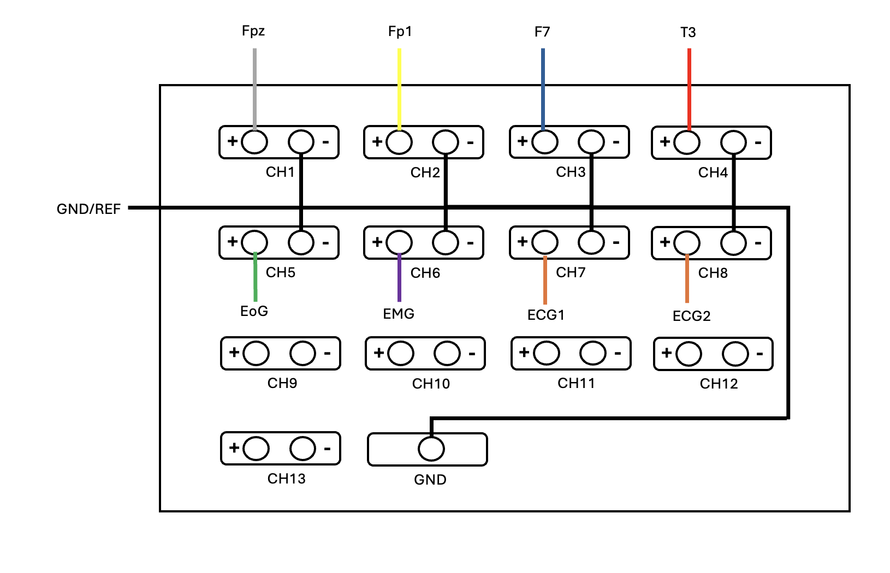
- Click on the rectangle icon in the top left of BrainVision Recorder software to check impedance values (Green or Yellow is good, Orange or Red is bad). Adjust or apply water if needed to reduce impedance.
- Check EEG signals by clicking on the “eye” icon.
- Have subject wear Fitbit on right wrist.
- Ask what temperature they prefer the room to be. Set the temperature.
- Ask what music or noise they prefer to play in the background.
- Inform and show a sample of a possible noise they would hear over the night (100Hz Square Tone).

E. Pre-Sleep STAI-S and HRV (~11:10PM)
- Connect 3-touch proof electrodes with 3M Red Dot to CH1+/- and GND in the configuration below. If subject is uncomfortable, you can ask them to place it themselves.

Electrode | Placement
CH1 + | RA
CH1 - | Middle of Sternum
GND | Under Ear

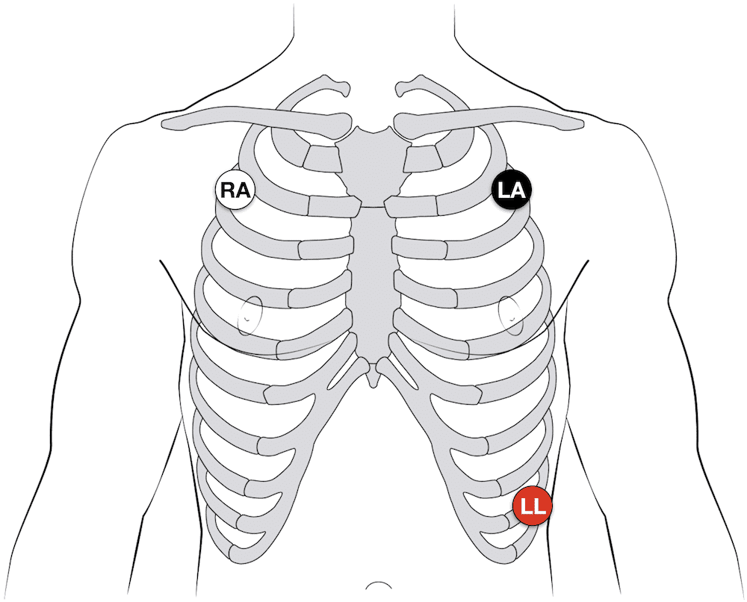
- Begin a recording for 5 minutes (ECG filename: sub00x-Dx-PreHRV).

F. Sleep Recording (~12AM)
- Begin a new recording (EEG filename: sub00x-Dx).
- Start stimulation of Arduino Serial Monitor starting at 12AM for every 90 minutes on Day 2. Otherwise, no stimulation on Day 1.
Time | FUS Block
12:00AM | 1
1:30AM | 2
3:00AM | 3
4:30AM | 4
6:00AM | 5

- Press restart button on Arduino before every new stimulation block.
- Monitor Heart Rate, SpO2, Camera, and electrophysiological recording throughout the night.
  - No sudden changes in Heart Rate (within 60-80 bpm).
  - SpO2 > 95%
  - Panic Alarm/Intercom
- If any of the above becomes issue, immediately check on the subject.
- Stop Recording at 7:30AM.
- Remove NEUSLeeP and Fitbit.

G. Post-Sleep STAI-S and HRV (~7:30-8:00AM)
- Bring subject to SEA 2.544.
- Perform full questionnaire (https://forms.gle/Z57iTSeC6treg23j9).
- Connect 3-touch proof electrodes with 3M Red Dot to CH1+/- and GND in the configuration below. If subject is uncomfortable, you can ask them to place it themselves.

Electrode | Placement
CH1 + | LA
CH1 - | Middle of Sternum
GND | Under Ear


- Begin a recording for 1 minutes (ECG filename: sub00x-Dx-PostHRV).

G. Clean-up (~8AM)
- Stop recording.
- Remove electrodes, NEUSLeeP, disconnect BrainVision (switch off).
- Charge BrainVision.
- Turn off Verasonics computer before turning off all other powers.
- Turn off EEG computer.
- Download and export data from Fitbit (Google Takeout and Fitbit Python API request) -> Check if data is present -> delete data afterwards.

Stress Adaptation fMRI -HARIRI Task
Filename: WANG_NEUSLEEP_STUDYB_00X

Screening and Subject Preparation
- Bring subject to at NHB MRI Lobby
- Ask participant to change into scrubs in the change room
- Go over brief overview of experimental procedure.
- Bring participant into MRI Control Room.

Setup Scan Room
- Prepare MRI (clean, setup, sheets, cushion)
- Setup button box (first = left, second = right)
- Setup 64CH Headcoil
- Setup laptop -> PsychoPy -> Hariri ver1 (day 1) or Hariri ver2 (day2) (vice versa for odds/even subjects)

Day | Odd Subjects | Even Subjects
1 | Hariri V1 | Hariri V2
2 | Hariri V2 | Hariri V1

- Ensure monitor displays tasks -> do a test run with button box
- If participants have vision issues, provide and test with MRI compatible optical glasses.
- Give earplugs to participant to use and bring them into the MRI machine. Position and place them in.
- Run scan sequences
- Take participant out, clean MRI machine.

Post-Experiment
- Bring participants to change clothes
- Notify participants that a follow up email requiring and detailing Individual Receipt Form for compensation.

NEUSLeeP Manual

Electrode | Color | Bipolar Input Box
Fpz | BROWN | CH1+
Fp1- | YELLOW | CH2+
F7 | BLUE | CH3+
T3 | RED | CH4+
EoG | GREEN | CH5+
EMG | PURPLE | CH6+
GND/REF | WHITE | REF (ALL CHX-)
GND/REF | BLACK | GND - REF


Voltage (V) | NEUSLEEP (Peak Pressure MPa)
 | 1 | 2 | 3 | 4 | 5 | 6 | 7 | 8
10 | 0.115 | 0.085 | 0.083 | 0.088 | 0.247 | 0.202 | 0.212 | 0.175
20 | 0.244 | 0.185 | 0.182 | 0.196 | 0.524 | 0.430 | 0.407 | 0.339
30 | 0.370 | 0.282 | 0.281 | 0.295 | 0.770 | 0.635 | 0.599 | 0.503
40 | 0.501 | 0.379 | 0.379 | 0.396 | 0.983 | 0.834 | 0.784 | 0.659
50 | 0.625 | 0.495 | 0.502 | 0.504 | 1.113 | 1.002 | 0.784 | 0.822
60 | 0.755 | 0.566 | 0.566 | 0.596 | 1.168 | 1.113 | 1.076 | 0.953

Delay  Variable (a.u) | NEUSLEEP (Focal Depth mm)
 | 1 | 2 | 3 | 4 | 5 | 6 | 7 | 8
50 | 23 | 26 | 23 | 28 | - | 24.5 | 23 | 26
60 | 28 | 32 | 30 | 34 | 32.5 | 29.5 | 30 | 33
70 | 35 | 40 | 38 | 43 | 37.5 | 37.5 | 36.5 | 40.5
80 | 39 | 45 | 44 | 49 | 46 | 41.5 | 43 | 46
90 | 39 | 50 | 48 | 53 | 52.5 | 47.5 | 50.5 | 52
100 | 50 | 62 | 57 | 58 | 50.5 | 56 | 57 | 60
110 | 55 | 66 | 60 | 64 | 60 | 61 | 55.5 | 65
120 | 59 | 68 | 67 | 69 | 61 | 66.5 | 66.5 | 69
130 | 64 | 72 | 72 | 74 | 64.5 | 67 | 73 | 97.5
140 | 67 | 78 | 76 | 76 | 70.5 | 72.5 | 80 | 80.5
150 | 71 | 85 | 84 | 79 | 77.5 | 76.5 | 88.5 | 82.5
160 | 77 | 91 | 86 | 84 | 85.5 | 85 | 91 | 85.5
170 | 79 | 94 | 88 | 88 | 86.5 | 86.5 | 95.5 | 97.5
180 | 86 | 98 | 98 | 90 | 93 | 89 | 97 | 100
190 | 89 | 99 | 99 | 99 | 98.5 | 96 | - | 97.5
200 | 92 | 100 | 100 | 98 | 96 | 98.5 | - | 98

Electrode | Placement
CH1 + | LA
CH1 - | Middle of Sternum
GND | Under Ear


Study B Experimental Procedure Checklist

1. EEG Room Setup (~10PM)
- ☐ Retrieve EEG room key
- ☐ Setup clean bedding in SEA 2.544
- ☐ Power and setup BrainVision Ex with amplifier
- ☐ Connect fiber optic cable, check BrainVision USB connection
- ☐ Launch BrainVision Recorder (select workspace NEUSLEEP-8CH-BIP)
- ☐ Confirm signal reception and camera operation (AMCap -> USB Camera)

2. Verasonics Setup (~10PM)
- ☐ Move Verasonics unit near computer
- ☐ Connect BNC cables and medical stand
- ☐ Connect OUTPUT TRIGGER to BrainVision trigger box
- ☐ Connect LEMO-00-BNC to Verasonics
- ☐ Power up sequence: Verasonics → wait 1 min → Computer → HIFU Power
- ☐ Launch MATLAB: activate, VSX, run protocol
- ☐ Adjust DelayParameter and test High Voltage P5
- ☐ Handle any errors (photo + contact Kevin)
- ☐ Open Arduino, select COM port, check prompt in Serial Monitor

3. Pre-Screening of Subjects (~11PM)
- ☐ Escort subject to clinical room
- ☐ Review experiment procedure
- ☐ Perform Stanford, Epsworth, STAI-S questionnaires
- ☐ Address questions

4. NEUSLeeP Setup (~11:30PM)
- ☐ Ask pillow preference
- ☐ Provide towel, instruct washroom use
- ☐ Place hydrogel, clean skin, mark position
- ☐ Attach NEUSLeeP and stabilize (gauze, tape)
- ☐ Connect BNC and EEG channels as per manual
- ☐ Check impedance (BrainVision) and EEG signals
- ☐ Provide Fitbit
- ☐ Apply ECG electrodes (RA, LA, LL)
- ☐ Set room temp, confirm preferred sleep noise

5. Pre-Sleep STAI-S and HRV (~11:10PM)
- Record Pre-HRV (5 min)

6. Sleep Recording (~12AM – 7:30AM)
- ☐ Begin EEG recording (filename: sub00x-Dx)
- ☐ Begin Arduino stimulation on Day 2 (every 90 min)
- ☐ Monitor vital signs (HR, SpO2), camera, EEG
- ☐ Respond to panic alarms or anomalies
- ☐ Stop recording at 7:30AM
- ☐ Remove NEUSLeeP and Fitbit

7. Post-Sleep STAI-S and HRV (~8:30AM)
- ☐ Perform full questionnaire
- ☐ Record Post-HRV (5 min)
- ☐ Remove NEUSLEEP and electrodes

8. Clean-Up (~8-9AM)
- ☐ Stop all recordings
- ☐ Disconnect and power off all devices in order
- ☐ Charge BrainVision
- ☐ Download/export Fitbit data, verify and delete after

